Maintenance and Help Guide

How to install the system:

1. Download the zip folder that contains the files necessary to run this site.

* 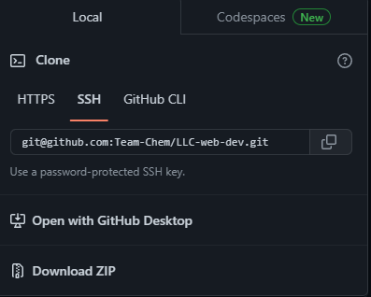
* There will be two folders within this zip file "app" and "db".

1. Software used to run localhost and phpMyAdmin:

* XAMPP - <https://www.apachefriends.org/download.html>
* This software has built in Apache and phpMyAdmin to run the localhost on your machine and allows the user to easily create and maintain a database.

1. How to use setup and use XAMPP:

* Go to the link in step 2 to download and install the XAMPP software for your corresponding machine.
* Once the software is installed, follow the file path and go into the “htdocs” folder.
* 
* This “htdocs” folder is where all the files for the code will have to be stored inside of. This allow the code to be rendered through Apache on the XAMPP software.
* If you want to have an organized file directory, you can create additional folders inside the “htdocs” folder and store the folders that contain the code.
* Graphical user interface

  Description automatically generated
* In the image above, there were 2 folders created in the “htdocs” folder. A folder for this current project and another folder inside the “project” folder that contains the code for this project.
* After this is done, you can boot up the XAMPP software.
* If you’re running the XAMPP software on Windows, set it to where when you launch the software it is launched through administrative mode. This will limit or eliminate all the problems that you will have with this software.
* When the software is launched, it should look like this.

* Press “start” for Apache and MySQL and click on “Admin” to open a new window.
* You will be redirected to a local dashboard page for XAMPP. This is how you know you know that Apache localhost is working.
* At the top of the page, you will see a “phpMyAdmin” button. When you click this, you will be redirected to the phpMyAdmin database page.
* Text

  Description automatically generated
* You can also access this page by clicking on the “Admin” button on the XAMPP Control Panel.
* Going back to the localhost dashboard page, a way to access the folders that contain the code is to go to the URL bar where is show “localhost/dashboard” and go to the correct file path.
* 
* Graphical user interface, text, email

  Description automatically generated
* localhost>project>capstone>app>views>pages.
* This file path will bring you into the pages folder where the pages will be rendered.
* After clicking on pages, the about page should be rendered and you can navigate through the website and access the features.
* 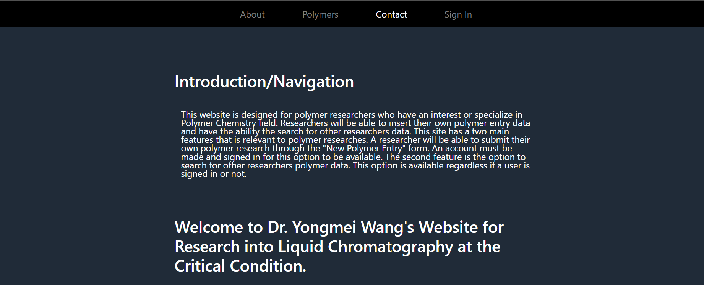
* You will have to create an account and sign in to access the buttons on the navbar that have been hidden from non-signed in users.
* Graphical user interface, application, website

  Description automatically generated
* A screenshot of a computer

  Description automatically generated

1. **Accessing the database**:

* Once you’ve clicked the “phpMyAdmin” button from the localhost/dashboard page you’ll be redirected to phpMyAdmin.
* Text

  Description automatically generated
* The database script will need to be imported to see the database that is needed.
* On the left-hand side of phpMyAdmin you will need to click the “new” button and name the database to “lccc_db”. Once this is don’t then click on the database and go to the top of phpMyAdmin and click on the “import” button.
* Graphical user interface, text, application, chat or text message

  Description automatically generated
* Graphical user interface, text, application

  Description automatically generated
* Graphical user interface, text, application, email

  Description automatically generated
* Import the database script and scroll down and click import.

* If the database schema has been successfully imported, then you will be shown a lot of success boxes.
* The database schema when clicked on should then look like this.
* Graphical user interface

  Description automatically generated

1. Known Issue 1 SQL Port:

* If you’re not able to click the “start” button on the XAMPP control panel it might be because the port is already being used.
* You can go to the services.msc process on Windows by pressing the windows key + R on keyboard to open the run menu. Type “services.msc” in the text box and run it.
* 
* Search for a process that is running that looks something like this. If it is running and not disabled, then this could be the reason why SQL won’t run. You will need to disable it and press the “start” button again on XAMPP Control Panel.

1. Known Issue 2 Database Schema:

* To import the database scheme, you must make sure to click on the “lccc_db” name before you can import it.
* Then go to the “import” button and import it.
* To know that you’ve successfully clicked on the db schema, look at the top of phpMyAdmin and you will see something like this.
* 

1. Known Issue 3 XAMPP:

* If you’re on Windows, make sure to run the XAMPP software as administrator every time.
* If this is not done, then you may experience a lot of weird bugs that there is not that much information online on how to solve them.
* This section is mostly for Window users.